Helpful Tips:

- To click, push on the trackpad, it is also the button.

- To right click, you can right-click by either holding down the control key and clicking, or by touching two fingers to the trackpad while clicking.
- To scroll, touch two fingers to the trackpad and move up/down/left/right.

Printing on campus:
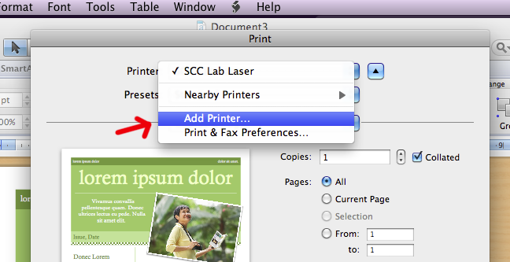
- Make sure you computer is connected to the network.

- Go to print the file you wish to print.
- Select print:
  - Windows: Select the printer you wish to use.

  - Mac: Select add printer and find the printer you want.

- Print to that printer.

Accessing the M: Drive using GCFile Online (goshenvpn):

- Double Click on the desktop icon, which says GCFile Online, or go to https://goshenvpn.goshen.edu/ in your web browser.
- Enter in your Username and Password and click Login.
- Click on gcfile or gcfile-Java to access your M: drive.

Using gcfile-java:

- To Upload a file, find the file you wish to upload on left. Find the folder on the M: Drive you wish to upload the file to, then you can just drag and drop the file to copy it.
- To Download a file, do the same thing but select the file from your M: Drive then copy it over to your computer using the drag and drop technique again.

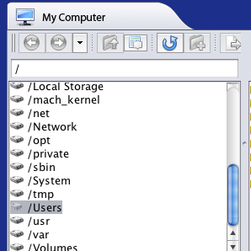
Mac Users:

If you are using a Mac OS X to access the GC File you will notice that your computer files aren’t readily available, in order to get to your files you need to click on the /Users (as highlighted) and then select the appropriate user file to get to the files on your computer.

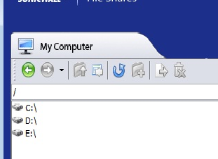
Windows Users:

Select the appropriate drive to access your files (usually C:\ is the right one).

Using the HTML gcfile:

- To Download a file using gcfile, just click on the file you wish to download.

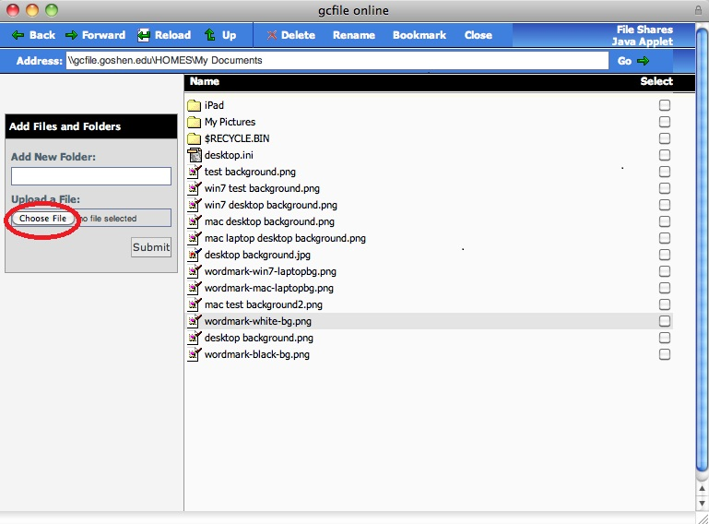
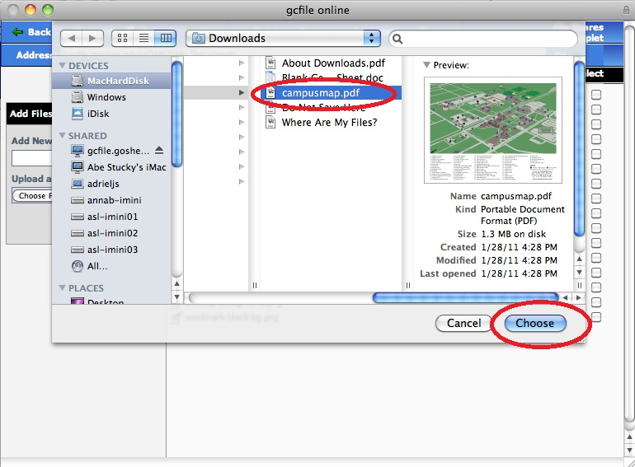
- To Upload a file, using gcfile click on the “Choose File” button and select the file you wish to upload. Click “Choose” then click “Submit”.

