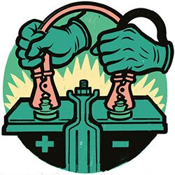
What To Do If Your Car Won’t Start
-or-
You Have a Flat Tire

Your car may not start for a number of reasons. If you have jumper cables, you’ll need to find another student on campus to help you jump start your vehicle. If you do not own your own jumper cables you can stop by the physical plant office during business hours and check out a set with your student ID. Physical Plant staff (or Campus Safety) will not be able to help you jump start your vehicle. If are unable to start your vehicle after a jump there may be something more serious wrong with it. Here are some options below for calling a repair shop or towing company depending on the issue.
Key locked in vehicle:
- First, check with your insurance. You may have coverage with roadside service.
- Call a locksmith (police do not provide this service).
In case of a flat tire, call Monteith Tire

Towing Companies Repair Shops

Thompson Towing
Address: 1407 Chicago Ave, Goshen, IN 46528 Monteith Tire – South
Phone: (574) 533-2570 Address: 2613 Caragana Court, Goshen IN 46526
Hours: 24/7 Phone: (574) 537-9797
Hours: 7:30am – 6:00pm (M-F)
Goshen Towing 8:00am – 1:00pm (Sat)
Address: 21825 County Road 38, Goshen IN 46526 Closed – Sun
Phone: (574) 533-0033
Hours: 8:30 am – 4:30pm (M-F)
11:00am – 12:00am (Sat)
Closed - Sun

Lock Smith
Jackie’s Lock Service Thom’s Locksmithing
Address: 1614 S. 8th Street, Goshen, IN 46526 Phone: (574) 305-0399
Phone: (574) 538-2090 Hours: 24/7
Hours: 24/7
- Cards Accepted: Mastercard, Amex, Discover, Vis Payment Types: Credit Card, Cash

