Performance Planning: A guide for employee development and feedback

Last Updated: May, 2015

Table of contents

Performance planning: Employee development and feedback at Goshen College

Introduction .......................................................................................................................... 3

Grow Goshen 2020: Goshen’s Academic Plan 2015-2020................................................. 3

Goshen College Mission...................................................................................................... 3

Goshen College Vision ..................................................................................................... 3

Goshen College Values........................................................................................................ 3

Goshen College Community Standards..............................................……………………….3

Performance Planning: Employee Development and Feedback Objectives.. . . . . . . . . . . . . . . . . . . 4

Increased Communication ................................................................................................. 4

Improved Performance ....................................................................................................... 4

Employee Development ...................................................................................................... 4

Human Resources Management......................................................................................... 4

Performance planning year-at-a-glance .............................................................................. 5

Six phases of the performance planning process ............................................................. 6

1. Planning.......................................................................................................................... 6

2. Goal Setting .................................................................................................................... 7

3. Monitoring ....................................................................................................................... 9

4. Coaching and feedback .................................................................................................. 10

5a. End of year discussion ...................................................................................................13

5b. Recognition ..................................................................................................................14
6. Growth and Development …………………………………………………………………….15
Appendix ................................................................................................................................ 16

GC Core Competencies Rubric

Performance planning: Employee development and feedback at Goshen College

Introduction
This guide is designed to assist leaders and employee in communicating about performance. Continuous application of these guidelines will ensure that employees know what is expected of them, how they are performing and what can be done to strengthen performance. In addition, development plans focus upon coaching and developing employees, helping them reach their full potential.

Our Time to Lead: Goshen College’s Strategic Plan 2015-2020
The Development and Feedback process allows employee members to understand how their work directly links and contributes to the mission, vision and priorities of Goshen College. Through their approach to their work, employee members can demonstrate the values of the institution as outlined in GC’s Strategic Plan. See plan:
https://www.goshen.edu/wp-content/uploads/sites/13/2015/04/Final-Strategic-Plan-2015-20.pdf

Goshen College’s Mission, Vision and Values

https://www.goshen.edu/about/mission/

Goshen College’s Community Standards

https://www.goshen.edu/employment/community-standards/

Note: Electronic guide can be retrieve on HR website under Supervisor Resources. This is recommended to ensure you use the latest version.

Performance planning: Employee development and feedback
Objectives
The four primary objectives include: Increased Communication, Improved Performance, Employee Development and Human Resource Management.

Increased communication
• Improving communication between leaders and employee
• Clarifying job responsibilities and standards
• Giving employee feedback on their performance

Improved performance
• Establish challenging performance goals in support of organizational objectives
• Encouraging individuals and work teams to strive for continuous improvement and quality
• Identifying and eliminating obstacles to performance

Employee development
• Focusing upon and addressing employee growth and career development
• Recognizing individual performance
• Optimizing employee skills, abilities and knowledge for mutual benefit

Human resources management
• Plan for development, resources and other issues

Performance planning year-at-a-glance
Goshen College’s annual performance planning cycle for employees runs from July –
June annually.

July | August – April | May – June
Step 1. Planning  Leader and employee member  Review the principal responsibilities of the job  Discuss standards of performance  Identify college priorities and department objectives  Decide upon projects within the scope of the position and assign specific goals and objectives  Step 2. Goal Setting  Leader and employee member  Review college and team objectives for the coming year  Define performance expectations that align with team and college objectives  Create SMART goals that will help to achieve team objectives and address professional development | Step 3. Monitoring  Leader and employee member  Meet regularly to review progress on performance goals to-date and discuss successes and roadblocks  Redefine expectations and update the goals if performance expectations change throughout the year  Step 4. Coaching and  Feedback  Leader  Provide ongoing feedback on the employee member’s performance  Establish open, ongoing communication channels  Employee member  Proactively solicit feedback to ensure that performance is in line with expectations  Leader and employee member  Provide objective information and examples of performance to identify areas of strength and areas for improvement throughout the year | Step 5. End of Year Discussion  Employee member  Provide comments related to the documented performance expectations and goals  Leader  Provide feedback related to the employee member’s performance expectations and objectives  Leader and employee member  Support each assessment with specific results and objective examples of performance throughout the year  Meet to discuss the employee member’s performance, identifying key areas of strength and accomplishment and areas for improvement  Step 6. Recognition and  Rewards  Leader  Recognize and reward performance frequently throughout the year. This can include simple verbal recognition and other forms of nonmonetary acknowledgement of good work
Deliverable:  Completed plan | Deliverables:  Regular meetings between leader and employee member  Updated (if necessary) | Deliverable:  Completed performance review

Six phases of the performance planning process
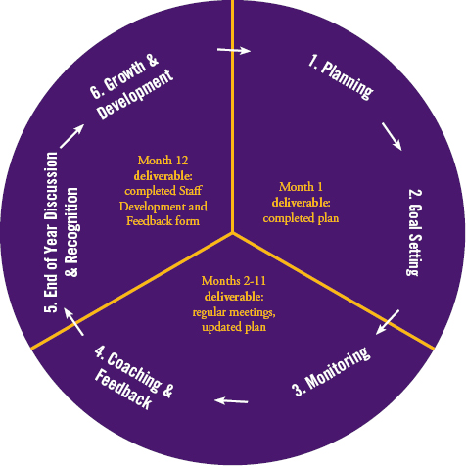

1. Planning
Planning is the first step in the cycle which the leader and employee member spend time planning for the coming year.

Planning includes a review of college and department/ team objectives to ensure that the employee member’s individual performance aligns with the college’s objectives and needs. In addition, the employee member and leader review principal responsibilities, determine projects and milestones to be achieved in the coming year and discuss standards of performance.

If the employee member is new, planning should take place during their first month of employment.

Principle responsibilities

Leader and employee member
• Review the principal responsibilities of the job (e.g., job description)
• Discuss standards of performance (e.g., Standards & Expectations)
• Identify college priorities and department objectives
• Decide upon projects within the scope of the position and assign specific goals and objectives
• Identify the knowledge, skills and abilities that need to be developed to achieve the goals and objectives
- Review GC Core Competencies to discuss expectations using the competencies rubric

Link to GC’s Strategic Plan
A major goal of planning is for the leader and employee member to explicitly identify the link between the employee member’s job responsibilities and performance and the objectives and mission of the department/ team and college. This alignment helps the leader and employee member prioritize work and establish measurements and performance standards that will be monitored throughout the year.

2. Goal setting
After the leader and employee member review the job responsibilities, establish performance standards and align the employee member’s performance objectives to the mission and objectives of the college and department/ team, the next step is to establish specific, measurable performance and development goals.

Principle responsibilities

Leader and employee member
• Define performance expectations that align with team and college objectives
• Define developmental objectives
• Create SMART goals that will help to achieve team objectives and address professional development

Performance goals
The performance goals define what is expected of the employee member during the year. They support the basic areas of responsibility and specific college, department or team goals. These goals may be addressed throughout the year or they could be associated with specific projects that involve a shorter timeframe. The purpose is to align the employee member goals with the goals and strategies of the college.

Developmental goals (Use GC Development Plan)
Development plans offer your employee the opportunity to identify the strengths and development areas that merit their attention and yours. Not all development plans are created equal, however. A good development plan focuses on the development of a few skills, balances the need to develop both strengths and development areas that are tied to your performance objectives, has concrete action steps, and sets gradual, realistic, and achievable success measures.

As you and your employees think about their development plans, remember the following:

• Performance and learning are linked to each other: Your employee can build the skills they need by focusing on the work experiences and assignments that are most closely tied to their performance objectives.
• While the skills may change, the strengths employee draw upon do not: The strengths
that have made a employee member successful in the past do not go away. Although they may need to address development weaknesses, do not forget to continue to build their strengths.
• Employee success depends on the people asked to help them: By sharing their
development goals with you, their peers, and/or a mentor, your employee can check in at various points to make sure that they are making a strong plan.

Writing SMART objectives
For objectives to be effective, they need to be clear, specific, realistic and measurable.

SMART Objectives

Specific | Describes what the end result will look like
Measureable | Expressed in quantifiable terms
Achievable | The objective is realistic
Relevant | Job-related and linked to the college’s and department’s goals (within job  duties)
Time-bound | Provide target dates

Sample SMART objective

"To recommend, ... | Achievable
...at the June... | Time bound
...department meeting, the three... | Specific
...vendors that best meet the defined criteria, at a cost that is at least 10% less than our present annual contract." | Realistic and Measurable

How do you write a SMART objective? Ask these questions.
1. Do what?
• Identify what visible action is to be taken – use action verbs: conduct, analyze…
• Describe what or whom the action will affect or whom it will involve

2. To what extent?
• Indicate qualities, timeframes, frequencies and other measurable results to be achieved
• How much is needed, by when and/or how often

3. For what results?

• Describe the desired end result, as well as the impact of that end result

4. How will the employee member know whether they’ve achieved the objectives?
• Develop key measures for each objective to help the employee member determine if they achieved what they set out to do
• Measures are the specific outcome expected, allowing the employee member and leader to monitor/evaluate success

Non-SMART objectives versus SMART objectives

Maintain department website | Ensure accuracy of the department website by conducting a comprehensive audit of the department’s website every two weeks. Work with leaders, employee and faculty in the department to edit information provided on the website. Make requested edits within two workdays.
 | Improve customer service by responding to all email and phone inquiries within 24 hours. Create a quarterly report detailing the number and types of inquiries received by the department.
Respond to all email and
phone inquiries
Write department handbook | Create a departmental orientation for new employees, introducing them to the technology, resources and policies and procedures of the department. Develop a departmental employee handbook and checklist for on-boarding new employees to our department. Present new materials to the department at the February employee meeting. Implement department orientation beginning March 1.
Database project | Improve the efficiency of logging and reporting inquiries to the department by creating a tracking system using Excel spreadsheets. Complete the tracking system by August 1. Train all front desk employee in how to use the system by September 1. Monitor and maintain the system and begin using it to generate quarterly reports by December 31.

Note: For employees, leaders should refer the Development and Feedback form. For all other employees, refer to the Performance Planning & Review form.

3. Monitoring
Monitoring is an ongoing effort throughout the year and a responsibility of both the leader and employee member.

Principle responsibilities

Leader and employee member
• Meet regularly throughout the year to review progress on performance goals to-date and discuss successes and roadblocks

• Redefine expectations and update the goals if expectations change throughout the year

Information management
Communication between the leader and employee member must be open, honest and ongoing. Employee can and should initiate the communication, particularly when any significant changes or obstacles occur that management should be aware of. Oftentimes responsibilities, projects, objectives and performance plans need to be modified as a result of changing circumstances and shifting priorities. Leaders and employee members are expected to keep each other apprised and current.

Self-monitoring
Since employees are aware of their own responsibilities, projects, objectives and skills, they are expected to monitor their own performance. Each s member is best able to measure their own performance against expectations and is encouraged to periodically keep their leader informed of progress and/or problems. Employee should keep track of their performance by documenting major activities and results whenever possible.

When employee have trouble making progress toward the achievement of objectives or responsibilities, they are responsible for taking suitable action to remedy the situation and close performance gaps. They may take action on their own or they may need assistance from their leader. It is incumbent upon each employee member to keep focused on their effectiveness.

Monitoring by leader
Throughout the review period, the leader monitors performance by reviewing and documenting work activities, milestones, costs, obstacles and results. They are aware if adjustments are necessary.

Consistent and accurate documentation during the review period facilitates regular feedback and end of year discussions.

Monitoring performance can be accomplished through formal and informal approaches. Some formal methods might include:

• Leader-Employee Member meetings
• Group or team meetings

When deciding your approach, you will want to consider factors that impact effectiveness, such as frequency of meetings; quality, quantity and format of information to be shared; and the desired outcomes. Formal conversations are not the only option to monitoring performance. Some situations might make informal conversations such as hallway chats appropriate for addressing very current work tasks and performance.

Performance log
The optional use of a Performance Log can help the leader in tracking performance and feedback given to the employee member throughout the year. A sample Performance Log is in the Appendix. Form can be retrieved from HR website under Supervisor Resources.

Management assistance
While self-development tends to be the most beneficial and effective, at times even superior performers need some assistance. Employee members are encouraged to seek out opportunities for discussion of their performance and development, including regular feedback and coaching from their leaders. Development is a shared responsibility best initiated by the employee member and supported by the leader. Leaders can use their experience, knowledge and skills to help track employee performance and provide the necessary support and opportunities for development.

4. Coaching and feedback
Throughout the year, both the leader and employee member monitor the employee member’s progress. Each has information regarding the performance to date. The coaching process provides a forum for the mutual exchange of this information. A leader’s role is similar to that of a coach in sports. An effective coach motivates, provides feedback, offers encouragement toward the achievement of goals and helps players to focus on the game plan.

Coaching involves two key leader activities:

• Providing constructive feedback to change or improve performance
• Recognizing and encouraging excellence

For an employee member to improve, develop or take on more responsibility, they need regular feedback on how they are doing. In addition, when they are performing well, their efforts should be acknowledged and supported. Coaching may be either formal or informal. Formal coaching involves setting aside time to meet privately, free from interruptions. Informal coaching is usually provided on a day-to-day basis as situations arise.

Principle responsibilities

Leader
• Throughout the year, provide ongoing feedback on the n member’s performance
• Establish open, ongoing communication channels

Employee member
• Proactively solicit feedback to ensure that performance is in line with expectations

Leader and employee member
• Provide objective information and examples of performance to identify areas of strength and areas for improvement throughout the year

Effective coaching
Effective coaching takes place when the leader and employee:

• Are prepared and informed
• Cite specific examples
• Focus on behavior, not personality
• Listen to each other
• Ask clarifying questions
• Reach agreement
• Develop an action plan
• Follow up

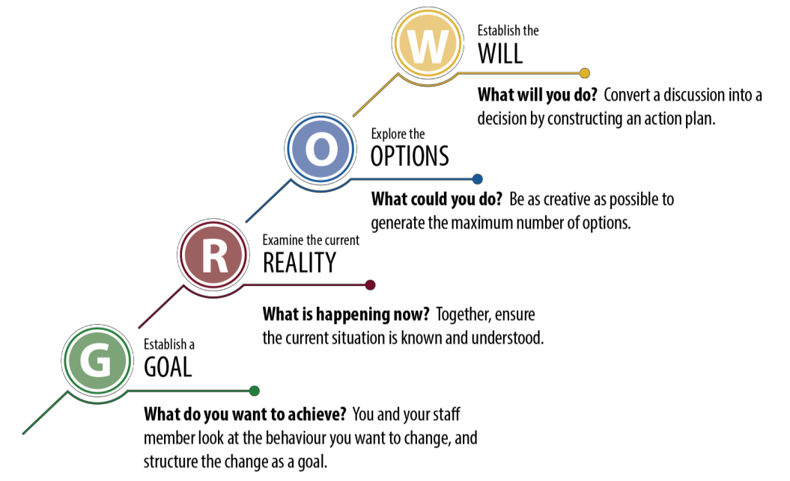
The GROW Coaching Model The GROW coaching
model provides a
structure to follow, so that the conversation can progress to a successful outcome. It is designed to be collaborative, powerful and intentional.

Step | Description | Sample leader questions
1. Establish a  GOAL | Key Question: What do you want to achieve?  You and your employee member look at the behavior you want to change, and structure the change as a goal.  • Positive  • Agreed to  • Understood | • What do you hope to achieve (in the short, medium, long term)?  • How will you know when you get there?  • Is it achievable?  • When by?  • When would you like to meet again to review this?
 | Key Question: What is happening now? Together, ensure the current situation is known and understood.  • Be objective (not opinions, judgments, expectations, prejudices, concerns, hope, fears)  • Be descriptive, not evaluative | • What is happening now (what, who, when, and how often)?  • What is the effect or result of this?  • Have you already taken any steps towards your goal?  • What is getting in the way?
2. Examine the
Current
REALITY
 | Key Question: What could you do?  Be as creative as possible to generate the maximum number of options (options the employee member may not have thought of before).  • Quantity, not quality or feasibility  • Challenge negative assumptions  • Look at the benefits and costs of each | • What are the options? What else?  • What are the advantages and disadvantages of each option?  • What factors or considerations will you use to weigh the options?  • How many ways are there to achieve your goal? Which appeal to you the most?
3. Explore the
OPTIONS
 | Key Question: What will you do? Convert a discussion into a decision by constructing an action plan. | • What are you going to do?  • What is your first step in this?  • What support do you need?  • On a scale from 1-10, how committed are you to doing this? What prevents your commitment from being a 10?  • When do you need to review progress? Daily, weekly, monthly?
4. Establish the WILL

5a. End of year discussion
Among the final stages of the process are the written feedback and the discussion. Human Resources recommend that all new employees receive feedback prior to the conclusion of their first three months, and that all others receive a feedback discussion annually.

Principle responsibilities

Employee member
• Provide comments related to the documented performance expectations and goals
• Self-Review: The employee member is encouraged to track their own performance and to keep a list of accomplishments and/or results relating to their documented performance goals, job responsibilities, objectives and professional development goals.

Leader
• Provide feedback related to the employee member’s performance expectations and objectives
• Leader’s Review: After the leader has received the employee member’s self-review and consolidated their own observations, notes, reports and other documentation, they provide feedback to the employee member.

Leader and employee member
• Support each assessment with specific results and objective examples of performance throughout the year
• Meet to discuss the employee member’s performance, identifying key areas of strength and accomplishment and areas for improvement

Preparation
Toward the end of the year, the leader and employee member should carefully review their notes, reports, observations and other documentation to prepare an accurate assessment. Performance throughout the entire year must be considered rather than just recent activities.

No surprises
If the leader and employee member have communicated consistently and continuously throughout the year, there will not be any surprises during the end of year discussion. It should simply be a culmination of previous communications. Surprises occur when there has been little or no specific communication regarding performance during the review period, a practice that is unproductive and contrary to organizational objectives.

Prior to the actual discussion, the leader is expected to give a copy of the completed form to the employee member. This gives the employee member an opportunity to plan for the meeting and facilitates two-way communication. For the discussion to be productive, the leader and employee member need to:

• Set aside at least an hour of uninterrupted time to meet
• Prepare a list of questions
• Anticipate possible questions
• Bring a copy of the completed form to the meeting
• Focus on actual behaviors and skills
• Actively listen to each other

TIP: Schedule meetings at least two weeks in advance. This gives the leader and employee member time to make final preparations for the discussion. Additionally, if a leader has multiple direct reports, setting appointments in advance helps to manage the demand on everyone’s schedule. The Performance Review Preparation Checklist found in the Tools and Templates Section can help you prepare.

Meeting
The meeting should be a two-way conversation in which leader and employee member:

• Review and discuss responsibilities, results, progress toward objectives and core behaviors
• Identify strengths, citing specific examples
• Identify development needs, citing specific examples
• Make any necessary adjustments to final ratings

TIP: Discussing weaknesses or developmental areas can be challenging, especially for new leaders. The Tools and Templates Section includes “Ten Tips on Delivering Performance Feedback on Weaknesses.”

Signatures and record keeping
At the conclusion of the meeting, the leader and employee member sign the last page of the form, signifying discussion of the review, and each receives a copy for their records. The original review is then forwarded to the second-level reviewer (the reviewer’s leader) for approval. A second-level reviewer signature is required to:

• Ensure that the discussions are conducted in a timely manner
• Check for possible rater bias on the part of leaders (harshness and/or leniency)
• “Red flag” any continued performance problems for further review
• Remain informed of progress and successes

5b. Recognition and rewards
Recognizing and rewarding performance should occur frequently throughout the year. This can include simple verbal recognition and other forms of nonmonetary acknowledgement of good work.

Principle responsibilities

Leader
• Recognize and reward performance frequently throughout the year. This can include simple verbal recognition and other forms of nonmonetary acknowledgement of good work

Recognition
Positive feedback for effective performance can be highly motivational. Suggested steps for giving positive feedback are:

• Describe the specific performance for which the employee member is being recognized
• Explain how the performance benefits the department and the college

• Express confidence in the employee member’s ability to maintain performance
• Thank the employee member

There are many opportunities for giving recognition. Some examples are to provide recognition when a employee member:

• Consistently meets or exceeds performance expectations
• Does a good job on routine tasks
• Is learning a new job or task
• Has improved their performance
• Accomplishes an especially difficult assignment or task
• Demonstrates a significant level of a particular skill
• Volunteers for a difficult or unwanted assignment
• Displays creativity in problem solving
• Discovers a way to save (or make) the organization money
Rewards
Some examples of rewards include:

• More autonomy
• Development opportunities
• Team projects, etc.

These and other examples will vary by individual, department and situation.

6. Growth and Development

See individual development form on HR website under Supervisor Resources for use. See Learning process in Appendix.

Appendix

Core Competencies Rubrics (Behavioral Descriptors)
Learning Process
Sample Performance Log
Sample Individual Development Plan (IDP)
Fixed versus Growth Mindset (addition to Continuous Learning competency)
List of Performance Appraisal Action Verbs

Customer Service Orientation

Definition: Understands that all employees have external and/or internal customers that they provide services and information to; honors all of the institution’s commitments to customers by providing helpful, courteous, accessible, responsive, and knowledgeable customer service.

Unsatisfactory Performer = NA or PA | Successful Performer = AE | Exceptional Performer = EE
ƒ Helpful: Fails to consistently follow through on  customer commitments | ƒ Helpful: Follows through on customer  commitments despite time pressures or obstacles | ƒ Helpful: Takes extraordinary action to meet  customer needs when required
ƒ Helpful: Uses common methods to solve the same  or similar customer problems without incorporating learning from past mistakes | ƒ Helpful: Recognizes when work processes and/or  outcomes are negatively impacting the customer; assumes ownership of the issue and takes appropriate steps to eliminate problems | ƒ Helpful: Recognizes that work processes and/or  outcomes are negatively impacting the customer; owns the issue and takes action to address deficiencies by identifying resolutions and notifying the appropriate leader
ƒ Courteous: Develops “shallow” relationships that  lack personal attention and focus, which result in low levels of customer satisfaction | ƒ Courteous: Develops relationships with customers  that are marked by attention and customer satisfaction | ƒ Courteous: Maintains positive, long-term working  relationships with clients; is adept at focusing individualized attention resulting in consistent,  high-level customer satisfaction
ƒ Courteous: Handles disgruntled customers in a  similar manner to all other customers, or reacts inappropriately | ƒ Courteous: Addresses disgruntled customer  problems by remaining calm and professional;  personally follows through to resolve issue(s) | ƒ Courteous: Addresses disgruntled customers  appropriately and takes action to resolve problems;  can defuse even the most upset customer situations with ease
ƒ Accessible: Meets customer needs but is difficult  to reach; takes an unreasonably long time in responding to customer requests and issues. | ƒ Accessible: Responds promptly to customer  requests; is easy to reach and work with during work hours; willingly works with customers to meet  their needs. | ƒ Accessible: Makes self fully available to the  customer by being flexible with time and schedule in order to provide services and information;  identifies ways to make services more accessible for customers to access.
ƒ Responsive: Does not seek new ways to enhance  the customer relationship with new service offerings | ƒ Responsive: Seeks out customer input to better  understand their needs; develops ideas for how to meet those needs | ƒ Responsive: Regularly updates understanding of  customers’ needs and quickly adapts solutions, as needed, to changing customer demands
ƒ Responsive: Ignores customer requests, “passes  the buck” to others, or is disrespectful in responding to customers’ needs | ƒ Responsive: Listens for and responds to customer  requests or problems in a timely manner | ƒ Responsive: Anticipates customer needs and  responds before the situation requires action
ƒ Knowledgeable: Does not demonstrates a  fundamental understanding of customer needs in his/her daily work; occasionally does not meet  customer expectations | ƒ Knowledgeable: Demonstrates a solid  understanding of customer needs by consistently meeting their expectations | ƒ Knowledgeable: Consistently exceeds customer  expectations by applying a solid understanding of what customers need and value
ƒ Knowledgeable: Tries to meet customer needs  but has difficulty identifying resources that could enhance the experience of each unique customer | ƒ Knowledgeable: Meets customer needs by acting  professionally and applying a good working knowledge of the services and information provided  by the institution or department. | ƒKnowledgeable: Helps others navigate the College’s system with greater ease by explaining the services offered and how to make contact with the Institution or appropriate department.

Collaboration

Definition: Cooperates with others to accomplish common goals; works with employees within and across his/her department to achieve shared goals; treats others with dignity and respect and maintains a friendly demeanor; values the contributions of others

Unsatisfactory Performer = NA or PA | Successful Performer = AE | Exceptional Performer = EE
ƒ Tends to isolate oneself from others while working toward team goals and objectives | ƒ Consistently works with others to accomplish goals and tasks | ƒ Frequently uses opportunities to work with others as a teaching tool to impart organizational knowledge and help others succeed
ƒ Sometimes treats other team members with  hostility or indifference | ƒ Treats all team members with a respectful,  courteous, and professional manner; supports team despite different points of view or setbacks | ƒ Actively seeks to eliminate “cliques” and  assists in problem solving so that all team members can be included in work processes
ƒ Talks about commitment to teamwork but  does not always demonstrate it in his/her actions | ƒ Considers the views of other people (and  departments, if relevant) when analyzing a situation or developing a solution | ƒ Builds loyalty among other team members (and departments, if relevant) across the institution
ƒ Works well with some people but not others;  is not generally regarded as a “team player” | ƒ Consistently works well with a variety of  different people; rarely encounters someone he/she cannot work effectively with on a task/project | ƒ Provides guidance to others as they work  through conflicts and disagreements so they can become better “team players”
ƒ Waits for others to solve interpersonal/team  conflicts and problems | ƒ Regularly initiates communication to help  solve interpersonal/team conflicts and problems | ƒ Facilitates communication between people  experiencing conflict who have previously been unable to solve problems
ƒ Inconsistently participates in  department and institutional meetings, activities, and events | ƒ Consistently attends and actively participates  in department and institutional meetings, activities, and events when asked or required | Volunteers on committees that are outside typical job responsibilities; exceeds the expectations of his/her job in participating in college initiatives and programs
ƒ Provides inconsistent feedback with different  members of the team | ƒ Provides balanced feedback to improve team  collaboration and functioning on a continuous basis | ƒ Proactively works with team members to  improve team collaboration and functioning on a continuous basis
Continuous Learning

Definition: Demonstrates a commitment to professional development by proactively seeking opportunities to develop new capabilities, skills, and knowledge; acquires the skills needed to continually enhance his/her contribution to the institution and to his/her respective profession

Unsatisfactory Performer = NA or PA | Successful Performer = AE | Exceptional Performer = EE
ƒ Takes advantage of learning opportunities only when they are presented to him/her or needs encouragement to take action | ƒ Engages in continuous learning opportunities to further develop skills and capabilities in technical and functional areas | ƒ Seeks out continuous learning opportunities that develop self and expands organizational intellectual capital
ƒ Ignores feedback from co-workers and  customers or becomes defensive; does not use feedback to improve performance | ƒ Uses feedback from co-workers and  customers to find ways of enhancing his/her performance | ƒ Proactively requests feedback from co-  workers and customers and uses it to enhance personal and team performance
ƒ Fails to recognize his/her own strengths and  development needs or does not seek ways to address those needs | ƒ Accurately identifies his/her own strengths  and development needs, leverages strengths, and takes action to develop areas that can be improved | ƒ Provides coaching to others to help them  leverage their strengths and effectively develop in areas where improvement is needed
ƒ Does not maintain ties with other  professionals in his/her field | ƒ Takes part in professional associations to  maintain a current knowledge base and relationships with others in his/her field | ƒ Participates in professional associations to  ensure he/she is visible to others in his/her field of expertise
ƒ Allows professional knowledge to become  antiquated; does not keep up with trends in his/her field of expertise | ƒ Updates professional knowledge and skills on  a regular basis to stay current and apply new trends or best practices to his/her work at the Institution | ƒ Shares new knowledge regarding  professional standards with others to ensure they are able to contribute new ideas to the Institution
ƒ Inconsistently demonstrates a growth mindset over a fixed mindset. (see appendix for explanation) | ƒ Consistently demonstrates a growth mindset over a fixed mindset. (see appendix for explanation) | ƒ Anticipates customer needs; stays abreast of  changes in the external environment and anticipates how they will impact his/her department and/or agency
ƒ Follows the steps in the Institution’s performance management program but is not committed to making the process work for himself/herself (e.g., linking performance to learning and development) | ƒ Actively participates in the Institution’s  performance management program, including focusing on improving performance through learning and development opportunities | ƒ Helps others enhance their experience with  the Institution’s performance management program by mentoring and coaching them through the process

Intercultural Orientation

Definition: Demonstrates an open-minded approach to understanding people regardless of their gender, age, race, national origin, religion, ethnicity, disability status, culture or other characteristics; treats all people fairly and consistently; effectively works with people from diverse backgrounds by treating them with dignity and respect

Unsatisfactory Performer = NA or PA | Successful Performer = AE | Exceptional Performer = EE
ƒ Does not recognize cultural differences; may use unfounded stereotypes to develop an understanding of others | ƒ Recognizes cultural differences among people and effectively works to bridge cultural gaps | ƒ Develops strategies for overcoming even the most challenging cultural differences to achieve common goals
ƒ Occasionally treats people differently  depending on culture, gender, race, socioeconomic, or other factor(s) | ƒ Treats all people with dignity and respect  regardless of cultural or socioeconomic background | ƒ Actively seeks to eliminate “out groups” so  that all people feel included and are free to be themselves
ƒ Works well with people who are similar to  him/her but has difficulty working with people who have different backgrounds | ƒ Effectively works with people of diverse  backgrounds regardless of personal differences that may exist | ƒ Thrives within the context of diverse teams;  capitalizes on diversity to find creative solutions and encourages other team members to leverage the diverse talents of employees
ƒ Sometimes makes statements that are  offensive or insensitive | ƒ Avoids making statements that may offend or  hurt others from different cultural or socioeconomic backgrounds | ƒ Consistently communicates even the most  difficult messages in a sensitive and supportive manner without compromising on the meaning of the message
ƒ Criticizes or disregards different opinions,  styles, or ways of working | ƒ Considers and honors different opinions,  styles, and ways of working | ƒ Helps other team members embrace the  value of considering and honoring different opinions, styles, and ways of working
ƒ Tolerates comments and actions of others  that reflect stereotypical views of people that are different from one’s self | ƒ Responds to and directly addresses  comments and actions of others that reflect stereotypical views of people that are different from one’s self | ƒ Proactively works to change views of those  that are intolerant of different people

LEARNING PROCESS
Learning takes time and patience. It is a process — a journey. A self-directed learning process is arguably the most powerful model for facilitating and inspiring individual, group and organizational learning and development.
We provide a learning process to empower people to guide themselves through their personal learning and development journey. This process is built upon three major principles:
- Identification of gaps between one’s IDEAL self and REAL self. These gaps represent a primary motivator to learn and improve.
- Creation and implementation of a challenging and realistic action plan for development that follows the70/20/10 formula.
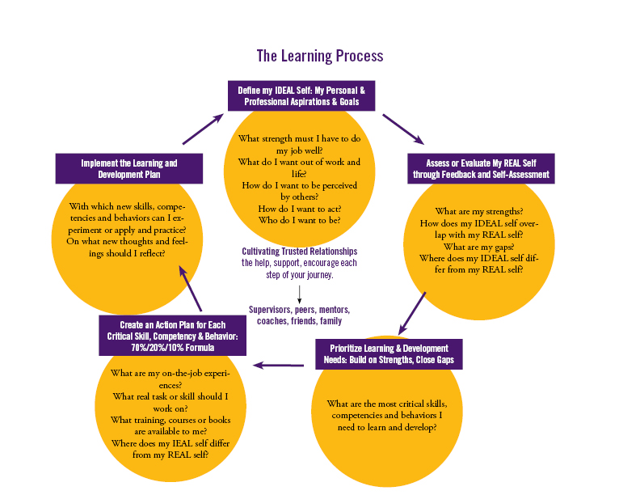
- Ongoing development dialogue between learners and supervisors. Both have a responsibility to ensure that the entire learning process happens.

Sample performance log
Use this worksheet to record performance-related information throughout the review period. Be sure to include the date you shared the information with the person, as well as the person's reaction. Also, record any follow-up items you agree on.
Staff Member’s Name: ___Seth____________
Date Shared | Feedback, Data or Information | Comments / Reactions | Agreed Upon Action Items
2/11 | Letter from Mary at ABC Enterprise (on file). Impressed with Seth's responsiveness to their technical problems. | Very pleased, of course! And surprised – he hadn't realized they appreciated the effort.
3/19 | Roger and Eileen both mentioned that Seth hasn't been returning phone calls promptly. In one case, it took more than a week. | Seth was already sensitive to the issue. He's in "serious overload mode." | Set meeting for 3/26 to review his responsibilities.
4/7 | 1st quarter results: 112% of target. | Relieved -Q1 target was ambitious. | Seth will continue to implement Q2 call quota results.

This form is on the HR website under Supervisor Resources

Professional development generally begins with a realization of current or future growth opportunities or needs, and the motivation to do something about it.

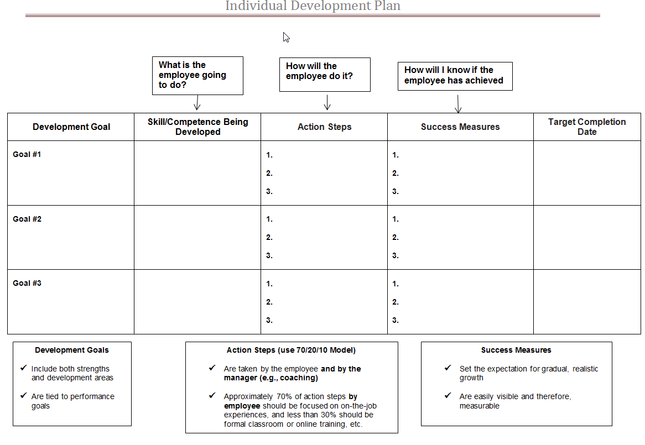
This form is on the HR website under Supervisor Resources.

70:20:10 is a reference model and not a recipe. The numbers are often considered simply to be historical artifacts. The importance and value of the model is that it extends learning beyond the classroom and course paradigm and utilizes workplace and social learning.
70:20:10 provides a framework for improving and extending traditional training and learning into the workplace. The '70' refers to learning within the workflow - workplace learning and performance support - and the '20' refers to social learning, including informal coaching and mentoring as well as building and exploiting strong and effective social networks.

70/20/10 Model. 28 January 2015. 20 May 2015 <http://en.wikipedia.org/wiki/70/20/10_Model>.

Fixed versus Growth Mindset
(Adapted from Carol Dweck’s work)

Goshen College’s competency of continuous learning consistently demonstrates a growth mindset.
FIXED MINDSET |  | GROWTH MINDSET
Intelligence is static. |  | Intelligence can be developed.
Leads to a desire to look smart and therefore a tendency to: |  | Leads to a desire to learn and therefore a tendency to:
- Avoid challenges |  | - Embrace challenges
- Give up easily due to obstacles |  | - Persist despite obstacles
- See effort as fruitless |  | - See effort as path to mastery
- Ignore useful feedback |  | - Learn from and seek feedback for ongoing growth
- Be threatened by others’ success |  | - Be inspired by others’ success

Below is a sample list of action verbs that can get you started with writing:

- Job duties or responsibilities for the positions in your College or Department

Example: Formulates recommendations based upon research conducted

- Goals for the staff members in your College or Department

Example: Expedite the response time required for inquiries from 3 days to 1 day by end of the fall semester

Communication/ | Communication/ | Creative Skills | Data/Financial
People Skills | People Skills |  | Skills
 | (continued) | Act | Administer
Address | Listen | Adapt
Advertise | Market | Begin | Adjust
Arbitrate | Mediate | Combine | Allocate
Arrange | Moderate | Compose | Analyze
Articulate | Negotiate | Conceptualize | Appraise
Author | Observe | Condense | Assess
Clarify | Outline | Create | Audit
Collaborate | Participate | Customize | Balance
Communicate | Persuade | Design | Budget
Compose | Present | Develop | Calculate
Condense | Promote | Direct | Compute
Confer | Propose | Display | Conserve
Consult | Publicize | Draw | Correct
Contact | Reconcile | Entertain | Determine
Convey | Recruit | Establish | Develop
Convince | Refer | Fashion | Estimate
Correspond | Reinforce | Formulate | Forecast
Debate | Report | Found | Manage
Define | Resolve | Illustrate | Market
Develop | Respond | Initiate | Measure
Direct | Solicit | Institute | Net
Discuss | Specify | Integrate | Plan
Draft | Speak | Introduce | Prepare
Edit | Suggest | Invent | Program
Elicit | Summarize | Model | Project
Enlist | Synthesize | Modify | Qualify
Explain | Translate | Originate | Reconcile
Express | Write | Perform | Reduce
Formulate |  | Photograph | Research
Furnish |  | Plan | Retrieve
Incorporate |  | Revise
Influence |  | Revitalize
Interact |  | Shape
Interpret |  | Solve
Interview
Involve
Join
Judge
Lecture

List of Performance Appraisal Action Verbs

Below is a sample list of action verbs that can get you started with writing:

- Job duties or responsibilities for the positions in your College or Department

Example: Formulates recommendations based upon research conducted

- Goals for the staff members in your College or Department

Example: Expedite the response time required for inquiries from 3 days to 1 day by end of the fall semester

Helping Skills | Management/ | Management/ | Organizational
 | Leadership | Leadership | Skills
Adapt | Skills | Skills
Advocate |  | (continued) | Approve
Aid | Administer |  | Arrange
Answer | Analyze | Navigate | Catalogue
Arrange | Appoint | Organize | Categorize
Assess | Approve | Originate | Chart
Assist | Assign | Overhaul | Classify
Clarify | Attain | Oversee | Code
Coach | Authorize | Plan | Collect
Collaborate | Chair | Preside | Compile
Contribute | Consider | Prioritize | Correct
Cooperate | Consolidate | Produce | Correspond
Counsel | Contract | Recommend | Distribute
Demonstrate | Control | Reorganize | Execute
Diagnose | Convert | Replace | File
Educate | Coordinate | Restore | Generate
Encourage | Decide | Review | Incorporate
Ensure | Delegate | Schedule | Inspect
Expedite | Develop | Secure | Log
Facilitate | Direct | Select | Maintain
Familiarize | Eliminate | Streamline | Monitor
Further | Emphasize | Strengthen | Obtain
Guide | Enforce | Supervise | Operate
Help | Enhance | Terminate | Order
Insure | Establish |  | Organize
Intervene | Execute |  | Prepare
Motivate | Generate |  | Process
Prevent | Handle |  | Provide
Provide | Head |  | Purchase
Refer | Hire |  | Record
Rehabilitate | Host |  | Register
Represent | Improve |  | Reserve
Resolve | Incorporate |  | Respond
Simplify | Increase |  | Review
Supply | Initiate |  | Route
Support | Inspect |  | Schedule
Volunteer | Institute |  | Submit
 | Lead |  | Supply
 | Manage |  | Standardize
 | Merge |  | Systematize
 | Motivate |  | Update
 |  |  | Validate

List of Performance Appraisal Action Verbs

Below is a sample list of action verbs that can get you started with writing:

- Job duties or responsibilities for the positions in your College or Department

Example: Formulates recommendations based upon research conducted

- Goals for the staff members in your College or Department

Example: Expedite the response time required for inquiries from 3 days to 1 day by end of the fall semester

Research Skills | Teaching Skills | Technical Skills
Analyze | Adapt | Adapt
Clarify | Advise | Apply
Collect | Clarify | Assemble
Compare | Coach | Build
Conduct | Communicate | Calculate
Critique | Conduct | Compute
Detect | Coordinate | Conserve
Determine | Critique | Construct
Diagnose | Develop | Convert
Evaluate | Enable | Debug
Examine | Encourage | Design
Experiment | Evaluate | Determine
Explore | Explain | Develop
Extract | Facilitate | Engineer
Formulate | Focus | Fabricate
Gather | Guide | Fortify
Inspect | Individualize | Install
Interview | Inform | Maintain
Invent | Instill | Operate
Investigate | Instruct | Overhaul
Locate | Motivate | Print
Measure | Persuade | Program
Organize | Simulate | Rectify
Research | Stimulate | Regulate
Review | Teach | Remodel
Search | Test | Repair
Solve | Train | Replace
Summarize | Transmit | Restore
Survey | Tutor | Solve
Systematize |  | Specialize
Test |  | Standardize
 |  | Study
 |  | Upgrade
 |  | Utilize

