Vol. 43 No. 3



The longest running departmental newsletter on campus.

Greetings:
With seniors graduating and May Term starting up, Goshen College is in its annual state of transition. I found myself sighing a breath of relief as I finished my last final of the spring semester, only to be caught off guard by how quickly my two May Term classes kicked into full gear just a few days later.

Psychology students and alumni have been busy with everything from preparing for grad schools to administering experiments and presenting their research. Below you’ll find a bit of insight into the events marking the culmination of students’ research as well as a quick peek into what psychology majors are up to post-graduation.
-Hannah Friesen, Department Assistant

Butler Conference:
On April 7, a group of junior and senior students attended the Butler Undergraduate Research Conference. The Conference includes research from a variety of disciplines and from colleges and universities across the country. Students gave 10 minute presentations to other undergraduates and professors on the results of experiments they had designed in the fall and administered in the spring semester. Brandon Vires & Barbara Hernandez-Walton’s presentation was titled Dishonesty Among College Students: Are College Students Likely to Cheat on a Test when the Results Lead to Monetary Reward (Self-Gain)? “Attending the conference was a unique experience; one that I think that most students should have before they graduate. It was fun to present our research to our peers at the conference, and I'm thankful to have had a wonderful partner, Barbara Hernandez-Walton, who helped throughout the entire process,” said Vires, a junior. “If I were to give some advice to someone who was looking to take this class, my advice would be to take the class! Nothing can replace the experience of conducting and presenting research. I look forward to conducting my own personal research in the future, and I will be looking to build off these experiences to help me.”

A second group of students, Maddy Graber, Emily Kauffman, and Nick Yoder, gave a presentation titled "Math is Hard": Replication of a Gender Priming Study (Steele & Ambady, 2006). “I really enjoyed listening to the presenters that came before us. It was inspiring to hear about how other groups’ process of conducting research compared to our own,” Kauffman, also a junior, says of her experience. “I also enjoyed learning from my group members Maddy and Nick. They are both incredibly gifted and intelligent human beings and I am really grateful for the energy they put into our project.”

The group of students and faculty are pictured below from left to right: Maddy Garber, Brandon Vires, Julie Reese, Amanda Sensenig, Emily Kauffman, Barbara Hernandez.

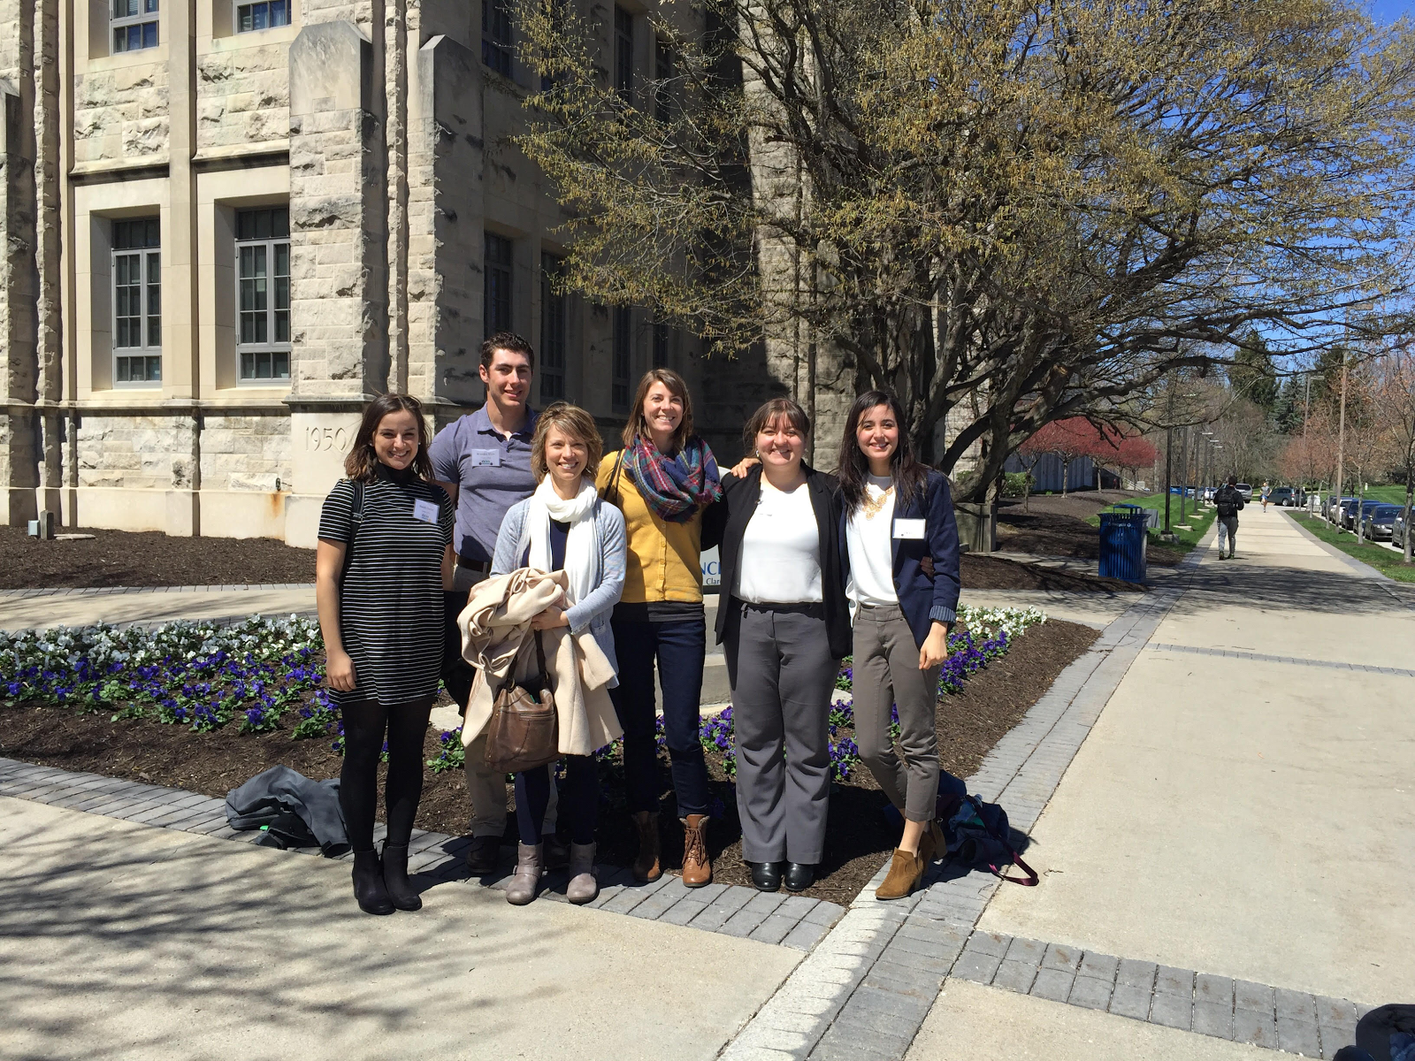

Alumni Updates:
A brief spotlight on two of our alumni:

Gladys Zolecko has been accepted to the University of Toronto Masters in Developmental Psychology and Education.

Maddie Ruth has been accepted to Tufts University School Psychology Program beginning this fall. She will be spending the next three years at Tufts earning her M.A. and Ed.S. with the goal of being a school psychologist.

In the Research:
Although the security and accessibility of information that comes with having a smartphone handy may be comforting to most the country’s population, new research shows that excessive attention to these devices comes at a price. This is significant information for especially college students, nearly half of whom report waking up in the night to answer phone calls or respond to text messages. Research by Karla Klein Murdock, PhD, shows that people who are more attuned to their phones subjectively report poorer sleep quality (as cited in Weir, 2017, p. 44). Another study by Russell E. Johnson, PhD, reveals that people who use smartphones for work at night function worse at work and were less engaged the next day than those who use laptops (as cited in Weir, 2017, p. 44). Social media is another realm of technology with the potential for great repercussions on human functioning. Research by Ethan Kross, PhD, suggests that scrolling through news feeds passively may have a negative effect on our emotional states. However, actively posting and otherwise engaging with people over social media can have either neutral or positive effects on people’s mood (as cited in Weir, 2017, p. 47).

References:

Weir, K. (2017, March). (Dis)connected. Monitor on Psychology, 48(3), 44-48.

